# COIT20256 Assessment Item 1 Report

|  |  |
| --- | --- |
| Student ID |  |
| Student Name |  |

This coversheet **must** be completed with your submission.

Please check (X) to indicate that you have satisfied these requirements

This work and my programming submission are my original work and no part of it has been copied from any other student’s work or any other source.

No part of this work or my code has been written for me by any other person/student.

I have taken proper and reasonable care to prevent this work and my code from being copied by another student.

I acknowledge that it is my responsibility to check that the file submitted is readable and complete and that the code submitted can be uploaded in NetBeans and will compile and run correctly.

I understand that plagiarism also includes the act of assisting or allowing another person to plagiarise or to copy my own work.

# **Instructions**

# Description of the Program and Phase Completed

Phase I

Following the class diagram provided in the figure, all the classes and its data members and methods are implemented in the first phase.

Phase II

In phase 2, OrderEvent is added that extends the abstract Event class. The class calls serveOrder() form the ShopModel class

Phase III

In this phase, LeaveEvent is added that extends the abstract Event class

Phase IV

This phase calculates the served customers and the loss business that is calculated from the left costumer that are not been served.

Phase V

The outcomes are displayed in the Statistics.txt file.

Phase VI

Providing random group size the program is tested.

# Testing

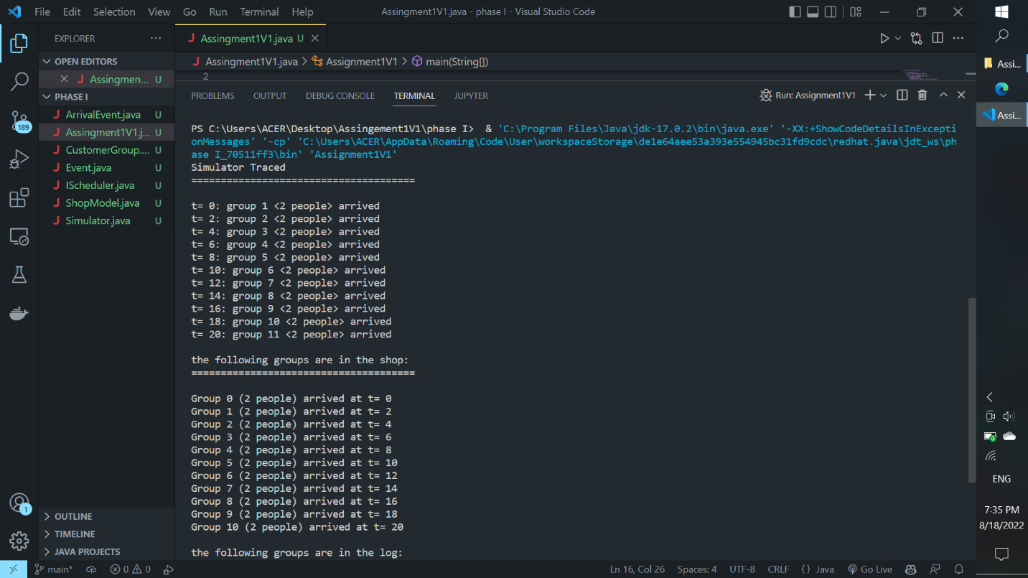

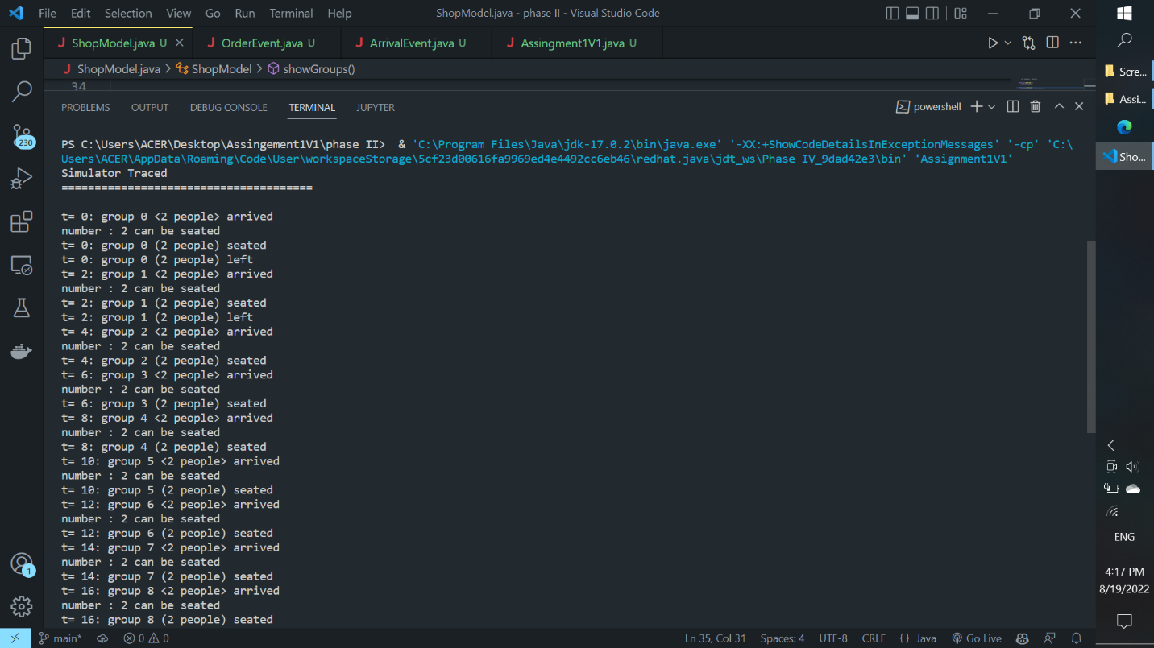

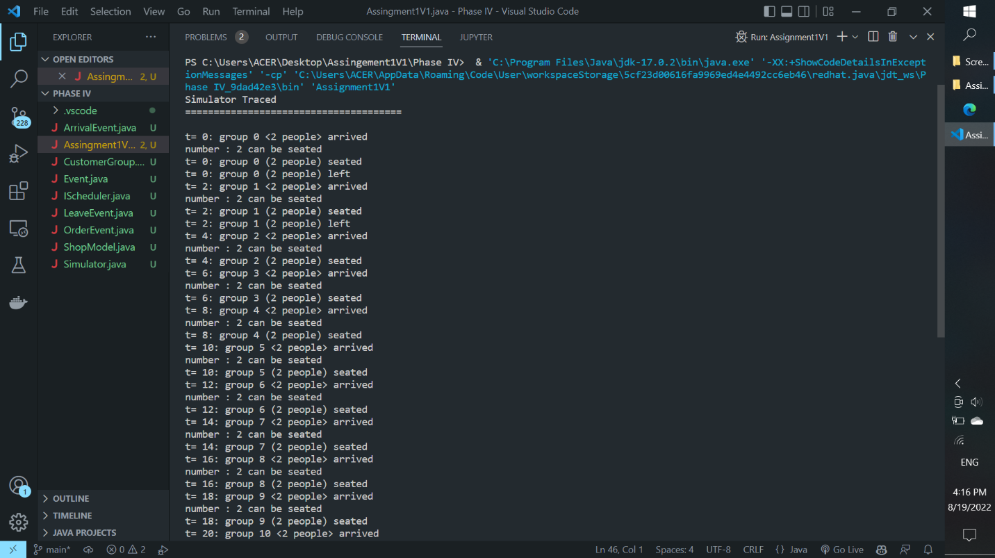

# Sample Output

## Simulation trace to the standard output:

## Phase I

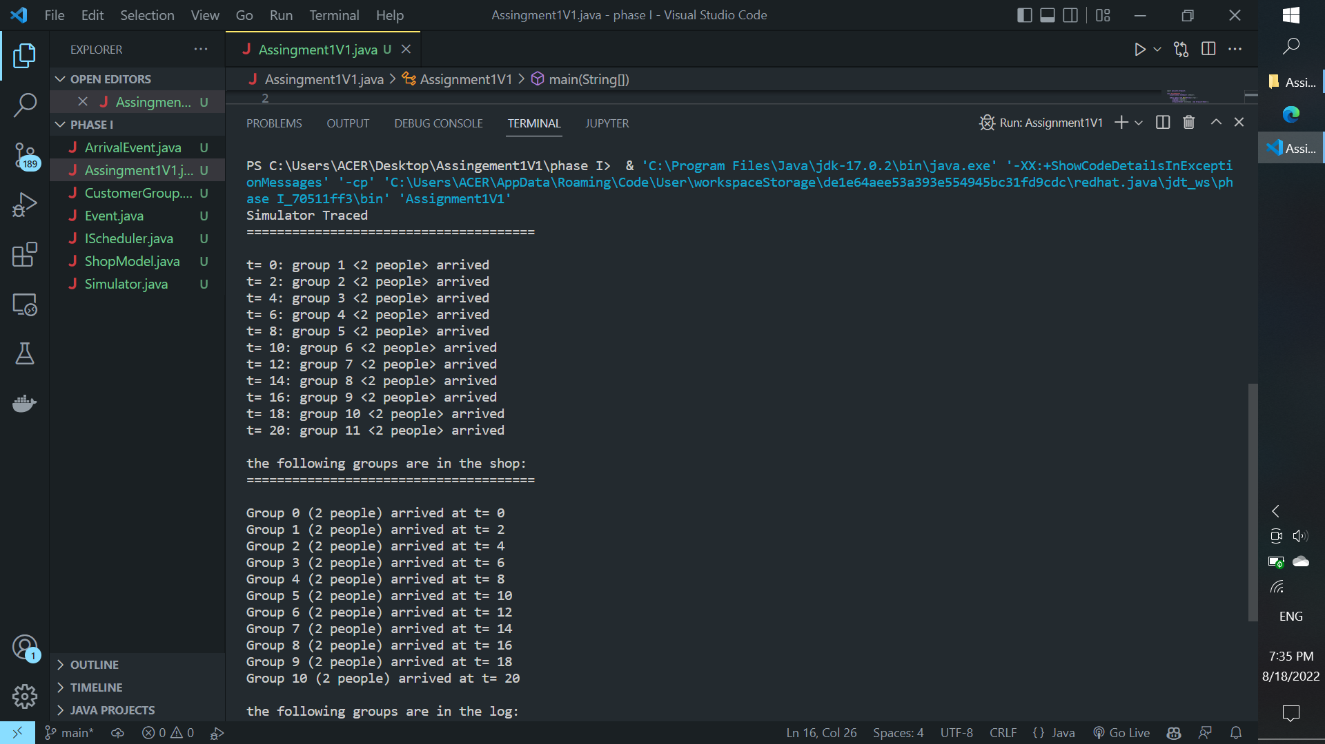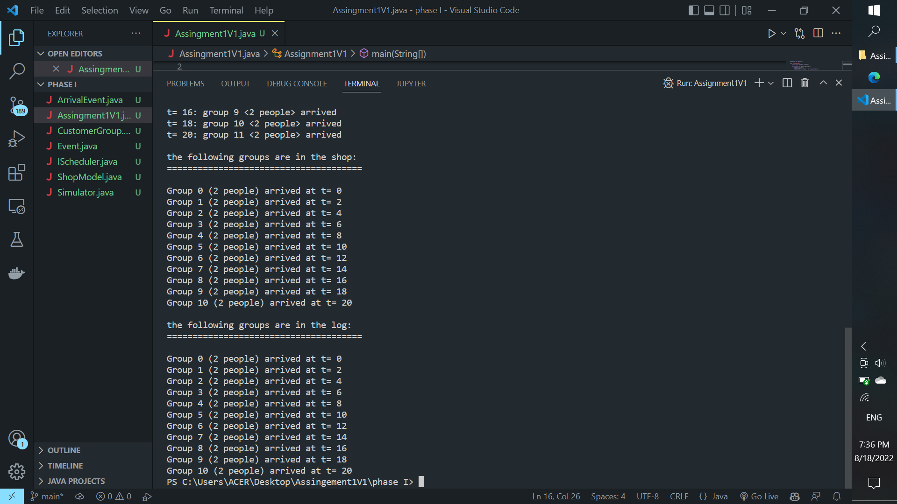

## Phase II

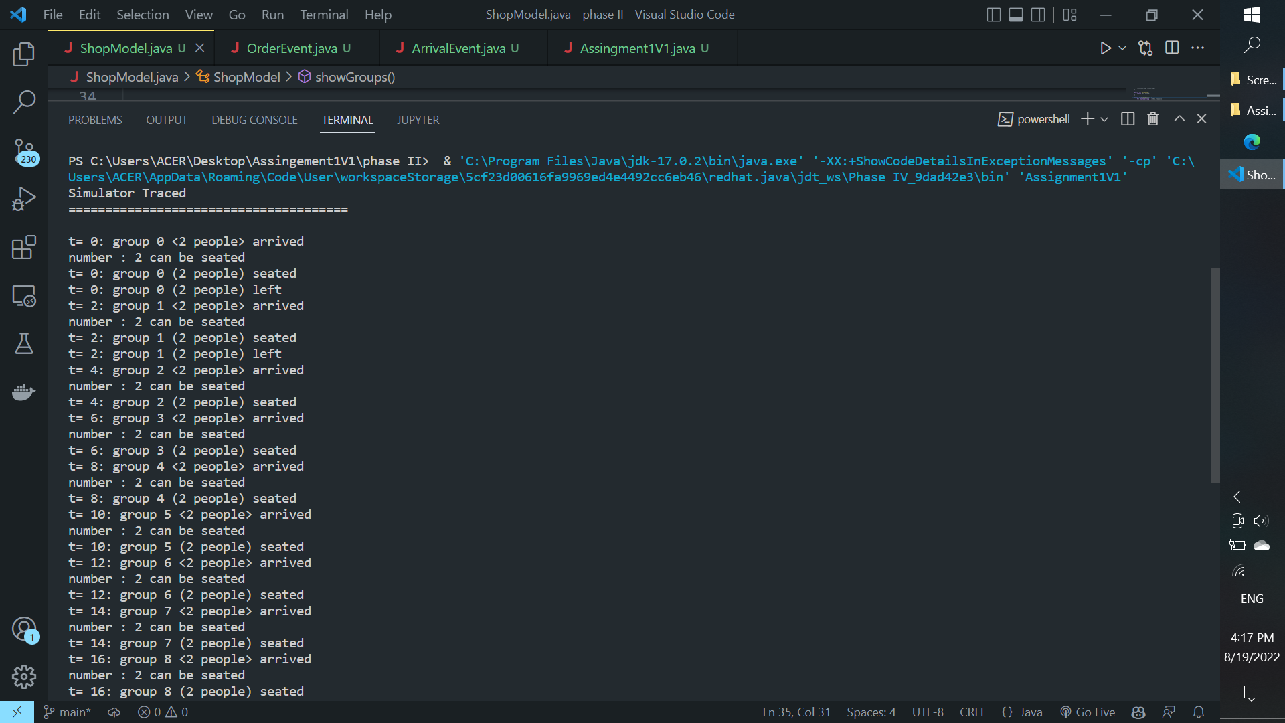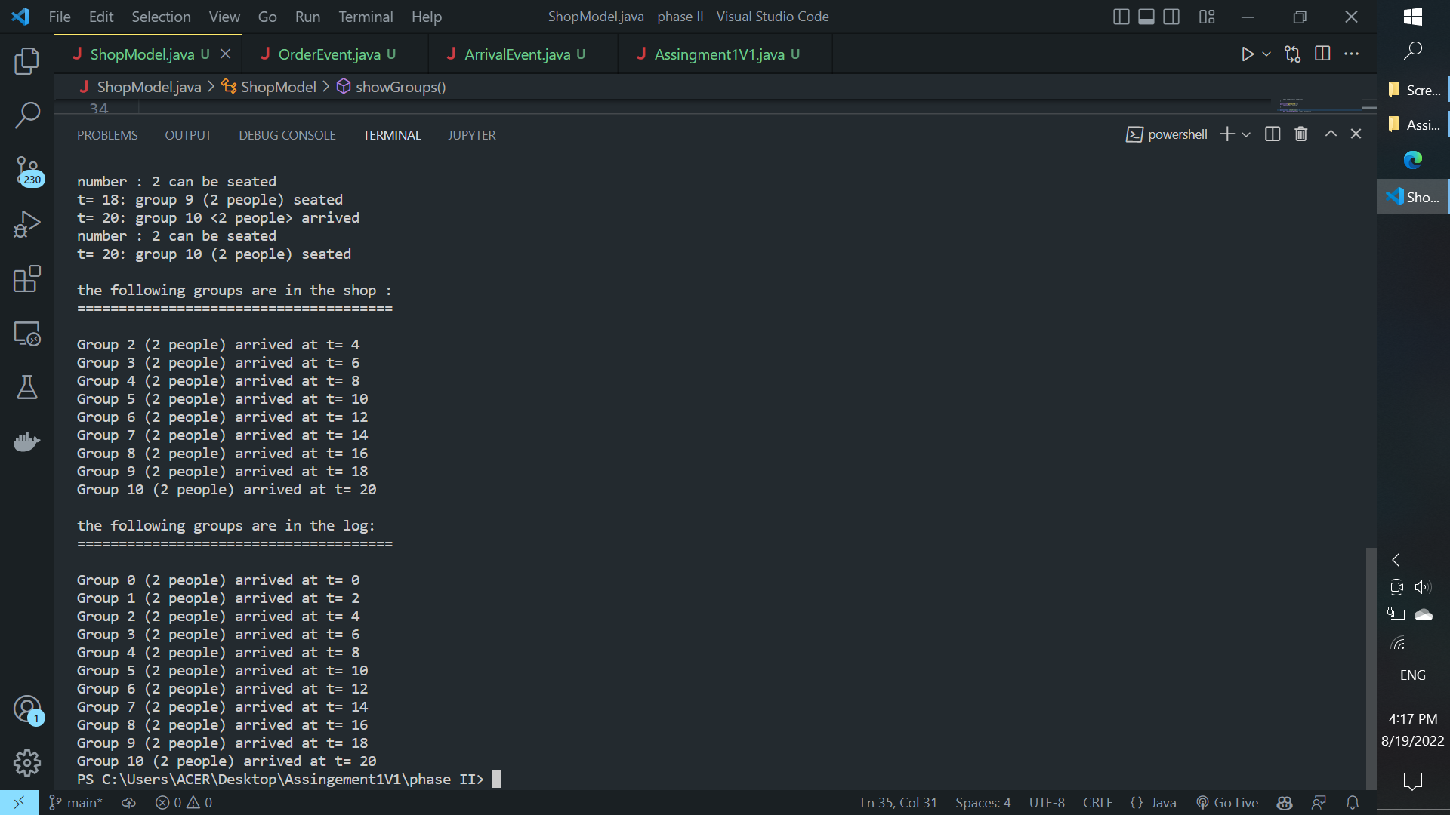

## Phase III

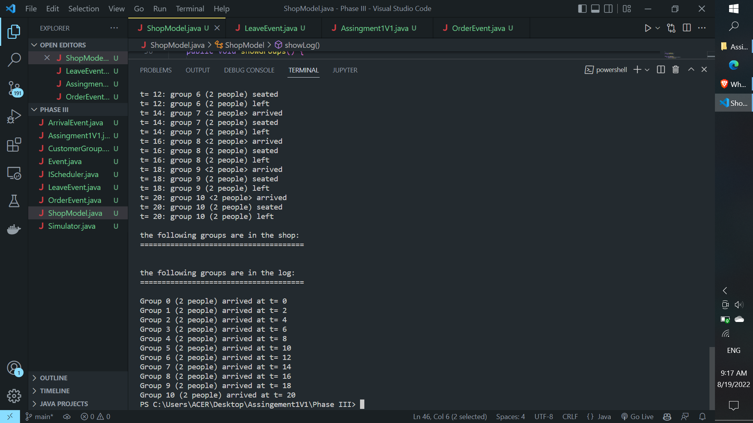

## Phase IV

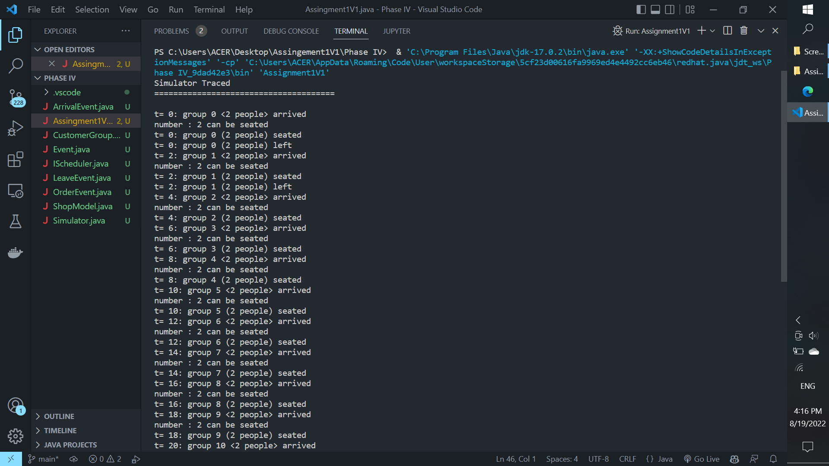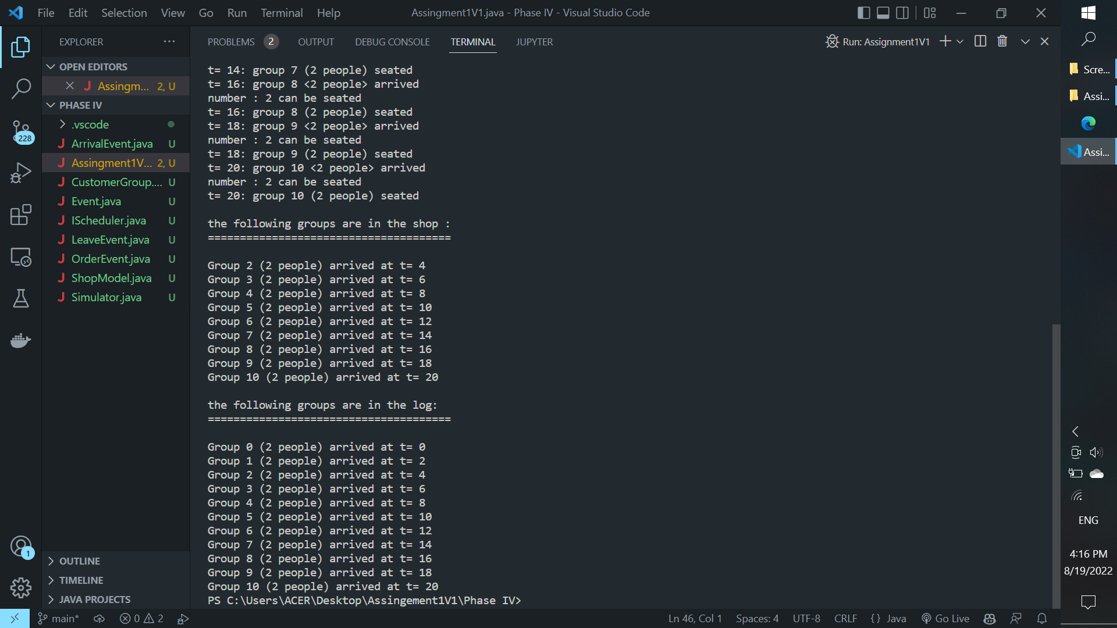

## Phase V

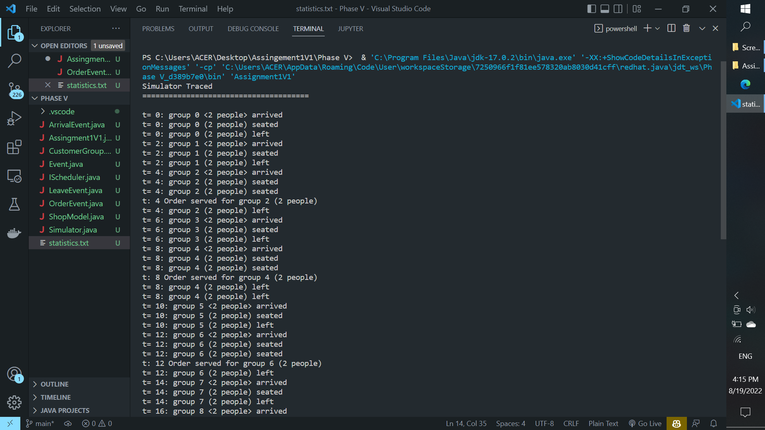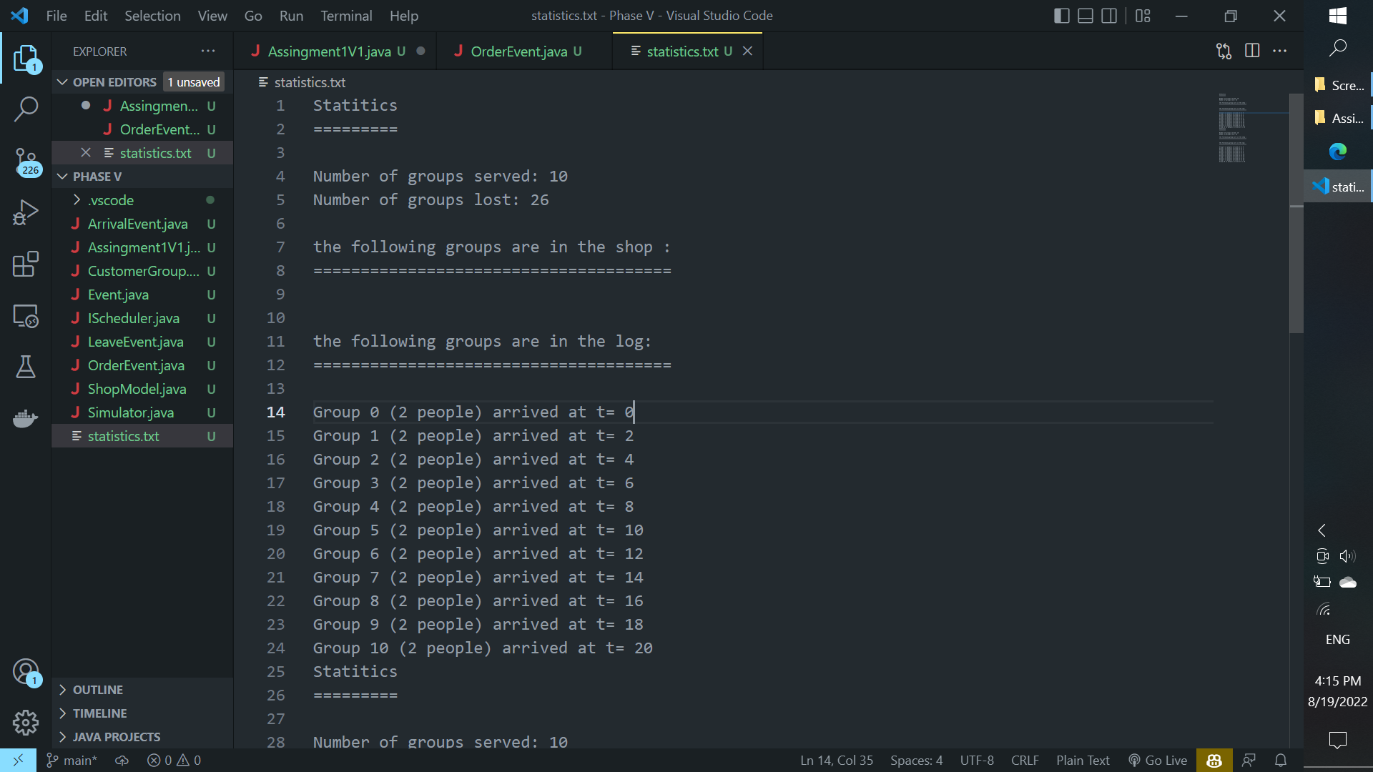

## Phase VI

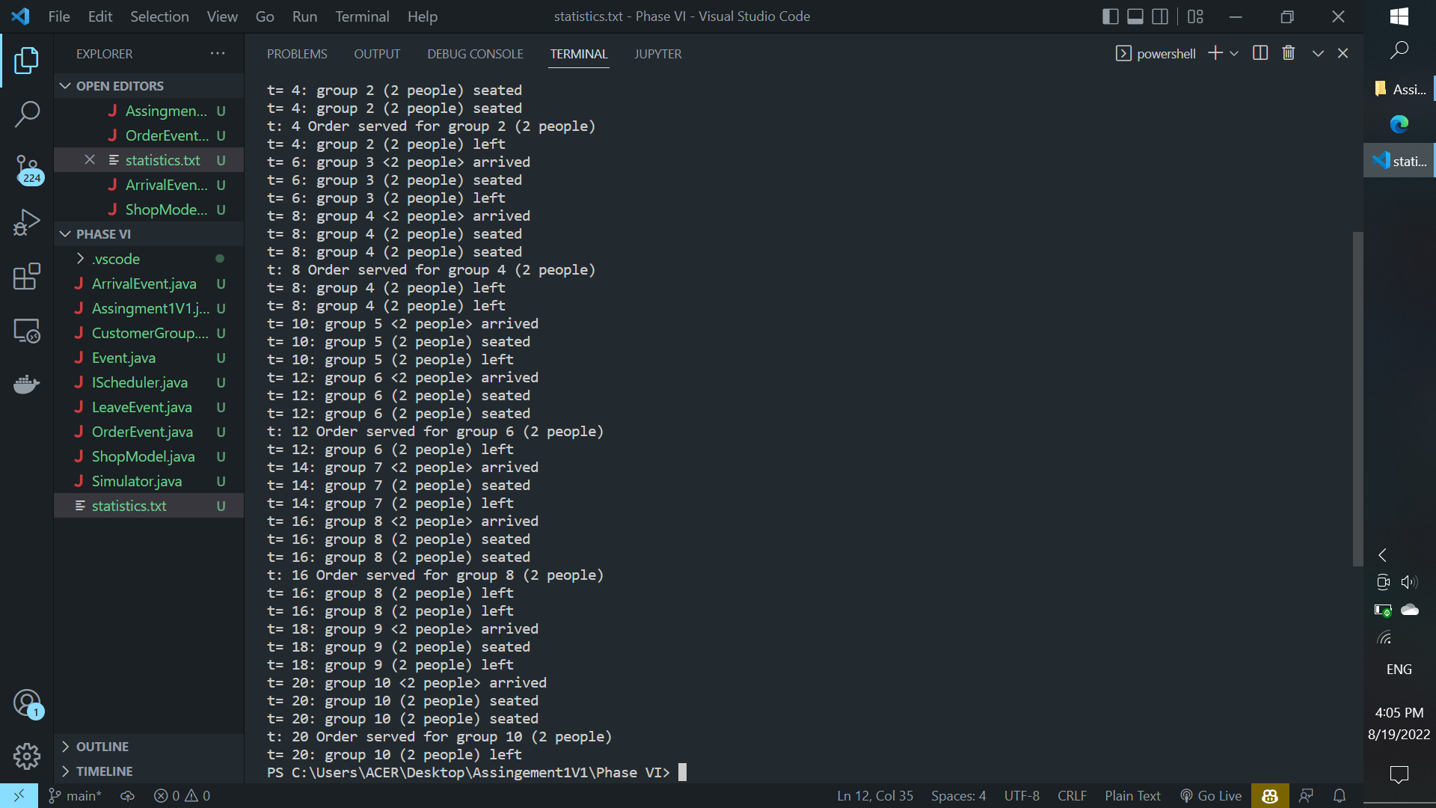

Statistics written to the statistics.txt file

Statitics

=========

Number of groups served: 16

Number of groups lost: 3

the following groups are in the shop :

======================================

Group 0 (1 people) arrived at t= 0

Group 1 (5 people) arrived at t= 2

Group 2 (5 people) arrived at t= 4

Group 3 (1 people) arrived at t= 6

Group 5 (2 people) arrived at t= 10

Group 6 (5 people) arrived at t= 12

Group 7 (3 people) arrived at t= 14

Group 9 (2 people) arrived at t= 18

Group 10 (3 people) arrived at t= 20

the following groups are in the log:

======================================

Group 0 (1 people) arrived at t= 0

Group 1 (5 people) arrived at t= 2

Group 2 (5 people) arrived at t= 4

Group 3 (1 people) arrived at t= 6

Group 4 (2 people) arrived at t= 8

Group 5 (2 people) arrived at t= 10

Group 6 (5 people) arrived at t= 12

Group 7 (3 people) arrived at t= 14

Group 8 (1 people) arrived at t= 16

Group 9 (2 people) arrived at t= 18

Group 10 (3 people) arrived at t= 20

Statitics

=========

Number of groups served: 10

Number of groups lost: 26

the following groups are in the shop :

======================================

the following groups are in the log:

======================================

Group 0 (2 people) arrived at t= 0

Group 1 (2 people) arrived at t= 2

Group 2 (2 people) arrived at t= 4

Group 3 (2 people) arrived at t= 6

Group 4 (2 people) arrived at t= 8

Group 5 (2 people) arrived at t= 10

Group 6 (2 people) arrived at t= 12

Group 7 (2 people) arrived at t= 14

Group 8 (2 people) arrived at t= 16

Group 9 (2 people) arrived at t= 18

Group 10 (2 people) arrived at t= 20

# Bugs and Limitations

## Bugs

The following code assumes that when after the customer leaves without served it is assumed as a loss business.

The code calculates that after the customer arrives into the shop, they are served after some fixed time period that is calculated within the program.

Similarly, the program assumes all the customer leaves after certain fixed time period.